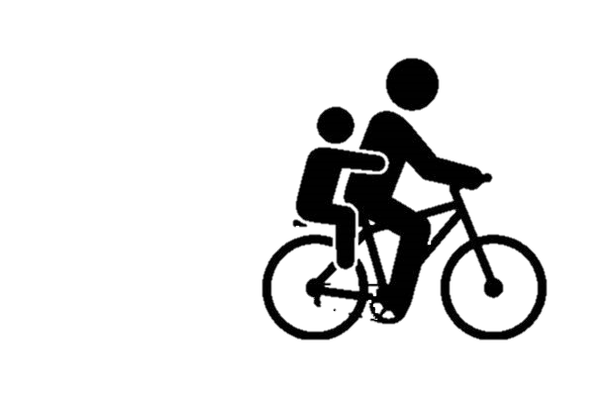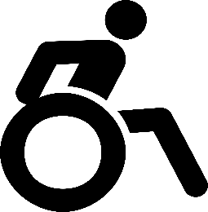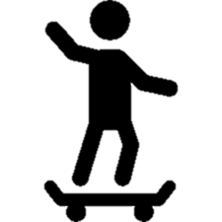

**<ENTER DATE>**Walk and Roll to School Day

**October is National Walk and Roll to School Month when schools across the country celebrate walking and rolling to school.**

Walk, bike, scoot, or skate to school with your friends and neighbors!

**ABOUT OUR EVENT:**